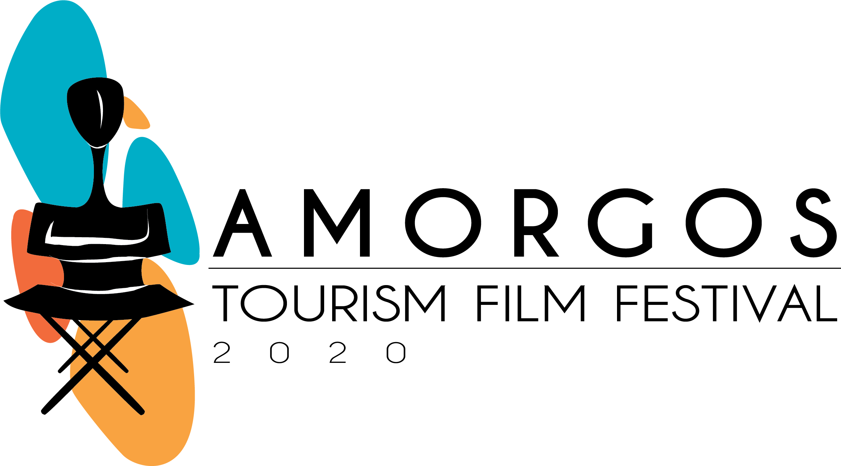

11th Amorgos Tourism Film Festival
2020 Winners

GrandPrix
Insiders Guide To Riga | Latvia
Special Award
Staycation | France | Special Jury Award
Documentary Section
A Sustainable Journey | Germany | 1st Prize
Storybooked: Inner Worlds | United States | 2nd Prize
Patagonia Park, A Journey into the Wild | France | 3rd Prize
Meraki | Portugal | Best Greek DOC
Elysia Yoga Convention 2019 | Greece | Best GreekTourism Film
Tourism Communication Section
Iceland Bike Farm | Slovenia | 1st Prize in Adventure tourism
As It Blooms | France | 2nd Prize in Adventure Tourism
Batalha – Find Your Senses | Portugal | 1st Prize in Cultural Tourism
40th Anniversary Of Madrid Pride | Spain | 1st Prize in Events, Fairs and Congress
Acting For Cannes, Acting For You | France | 1st Prize in Events, Fairs and Congress
Alentejo Enotourism | Portugal | 1st Prize in Enotourism
Seize The Moment - Santo Maris Oia Luxury Suites & Spa | Greece | 1st Prize in Hotels & Resorts
Barut Collection | Turkey | 2nd Prize in Hotels & Resorts
Arriving Together | Austria | 1st Prize in Nature and Rural Tourism
Timeless Time | Germany | 1st Prize in Nature and Rural Tourism
Gran Canaria, Fairytale Island | Spain | 2nd Prize in Nature and Rural Tourism
Pampilhosa Da Serra - Nature's Shopping Centre | Portugal | 2nd Prize in Nature and Rural Tourism
Connected ByTrail | South Africa | 1st Prize in Sports Tourism
Goethes Airport | Germany | 1st Prize in Tourism Services
TheTurn Key Club | Portugal | 1st Prize in Tourism Services
At Home | Greece | 1st Prize in Independent Travel Video
Italia: Where Wow Belongs | Italy | 2nd Prize in Independent Travel Video
Insiders Guide To Riga | Latvia | 1st Prize in Tourism Destinations - City
What Makes An Extraordinary Story #Inabudhabi? | Abu Dhabi | 2nd Prize in Tourism Destinations - City
We Love Zagreb | Croatia | 3rd Prize in Tourism Destinations - City
Gran Canaria, Fairytale Island | Spain | 1st Prize in Tourism Destinations - Region
Memories Of Destination | India | 2nd Prize in Tourism Destinations - Region
What Would You Like Your Children To Remember? | Spain | 3rd Prize in Tourism Destinations - Region
Turismo Centro Portugal – Are You Ready? | Portugal | 3rd Prize in Tourism Destinations - Region
Arriving Together | Austria | 1st Prize in Tourism Destinations - Country
Azerbaijan: Take Another Look | Azerbaijan | 2nd Prize in Tourism Destinations - Country
See Serbia | Serbia | 3rd Prize in Tourism Destinations - Country

